**AIM:** Write a C program to implement the Tree Traversals (Inorder, Preorder,Postorder)

**ALGORITHM:**

### ****Inorder Traversal (Left → Root → Right)****

1. Traverse left subtree (Inorder).
2. Visit root node.
3. Traverse right subtree (Inorder).

### ****2. Preorder Traversal (Root → Left → Right)****

1. Visit root node.
2. Traverse left subtree (Preorder).
3. Traverse right subtree (Preorder).

### ****3. Postorder Traversal (Left → Right → Root)****

1. Traverse left subtree (Postorder).
2. Traverse right subtree (Postorder).
3. Visit root node.

**CODE:**

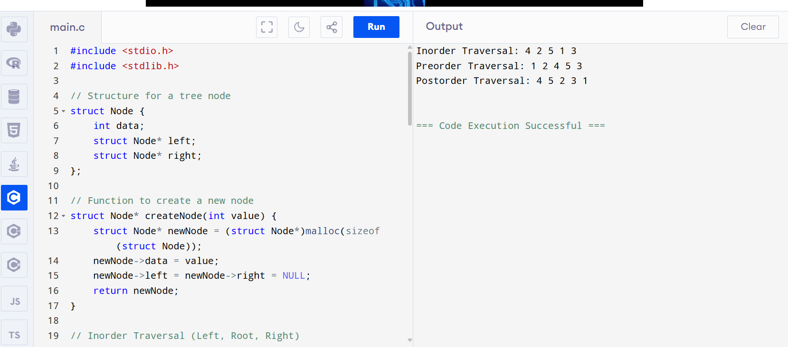

**OUTPUT:**

Inorder Traversal: 4 2 5 1 3

Preorder Traversal: 1 2 4 5 3

Postorder Traversal: 4 5 2 3 1

=== Code Execution Successful ===